

**KHULNA UNIVERSITY OF ENGINEERING & TECHNOLOGY**

Department of Electronics & Communication Engineering

**Report on :**

**Adjustable , Regulated and Protected DC Power supply**

Course No : ECE-2200

**Group:B 6**

**Project Supervisor: Submitted by:**

**Dr. Md. Mostafizur RahmanAditi Bose (1209046)**

**Mr. Md. Mehedi Hasan Soumen Biswas (1209047)**

**Nazia Suraia Usha (1209048)**

Date of Submission: **13/01/2015**

**Contents:**

* Objectives
* Introduction
* Circuit diagram
* Components
* Circuit analysis
* Result analysis
* Cost analysis
* Discussion
* Conclusion
* Fields to Develop
* References

1 : Objectives

Main objectives of this project is to design and fabricate a DC power supply which is:

-Adjustable (0-35V)

-Regulated

-Over Voltage Protected

-Under Voltage Protected

-Over Current/Short Circuit Protected

-Transformer Protected

- Providing Uninterrupted Supply

-Light Weight & Lower Cost

2: Introduction

The most essential part of an electronic circuit is a power supply. Every electric device, from smaller to the larger one needs an external power supply. In Laboratories, a DC power supply is a must. But all devices can’t be operated at same voltage. Each device has its own optimum ratings, which we can’t exceed. So, such a power supply is needed which is adjustable that is a user might get desired voltage from it. In this project we tried to design and fabricate such a power supply that will be user friendly and will be commercially lower cost having a light weight. Almost all electronic equipment has its maximum ratings. If by any fault of the device, it exceeds its maximum rating then our power supply will automatically switch the output off without doing further hamper. This power supply provides the necessary protection and voltage, current ratings suitable for general operation of practical electronic component or for laboratory use as a variable DC power source with all necessary indication.

3: Circuit Diagram

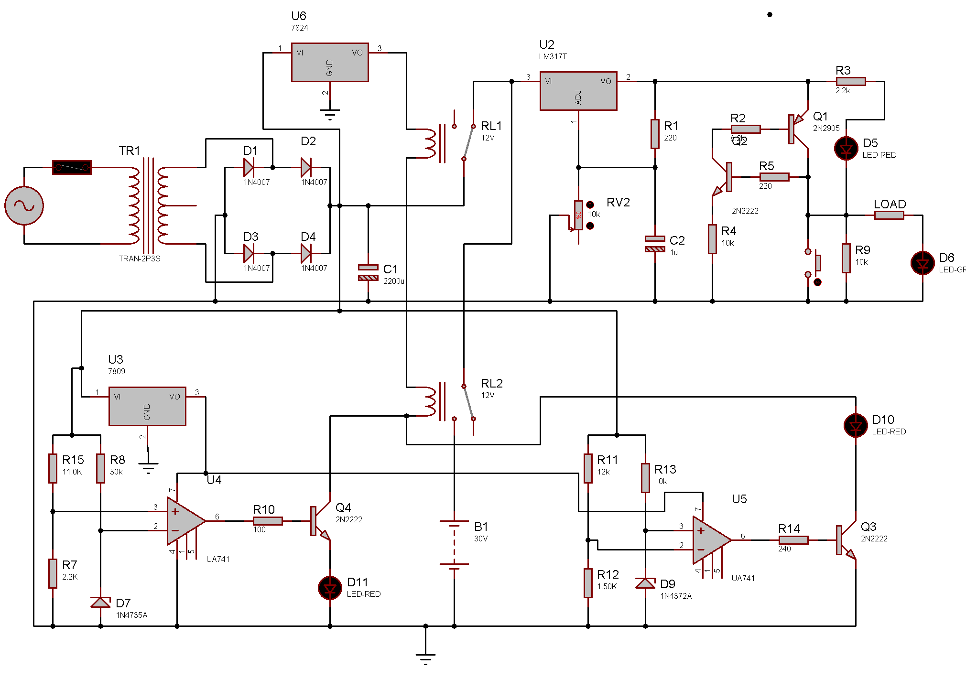

Fig-1.1: Circuit diagram of DC power supply.

4: Components

* Transformer- 1 piece (220V to 24V,1A)
* Diode-6 pieces(1N4007)
* Zener Diode-2 pieces(6V,3V)
* Capacitor-3 pieces(2200uF,10uF,1uF)
* Resistor-14 pieces
* Op-Amp-2 pieces(LM741)
* Adjustable regulator IC-1 piece(LM317)
* Fuse – 1 piece (1 amp)
* Regulator IC-2 pieces(LM7809,LM7824)
* Variable resistor-3 pieces(10k, 5k)
* Transistor-4 pieces(2N2905-1 ,2N2222-3)
* Relay-2 pieces(12V)
* Battery -1 pieces (30V)
* LED-4 pieces(Red-3,Green-1)
* Switch – 1 piece

5: Circuit Analysis

5.1 **TRANSFORMER PROTECTION &BRIDGE RECTIFIER WITH FILTER:**

To protect the transformer from over current of supply ac voltage we use a FUSE at the input terminal of the transformer. The rating of the FUSE is 1 Amp. So if the current flow is over 1 amp then the Fuse will be cut and the transformer will be protected from being damaged.

Our main objective is to make a dc power supply. For that reason we use bridge rectifier circuit. It contains four diodes connected to form bridge. We use 1N4007 series diodes. For the positive half cycle of a.c. signal diodes d1 and d2 are forward biased and diodes d3,d4 are reversed biased. During the negative half cycles of a.c signal diodes d1, d2 are reverse biased and diodes d3, d4 areforward biased. As a result we get d.c output all the time which is pulsating d.c. Then we have used a capacitor C1 for filtering. After this we have got pure d.c power supply.

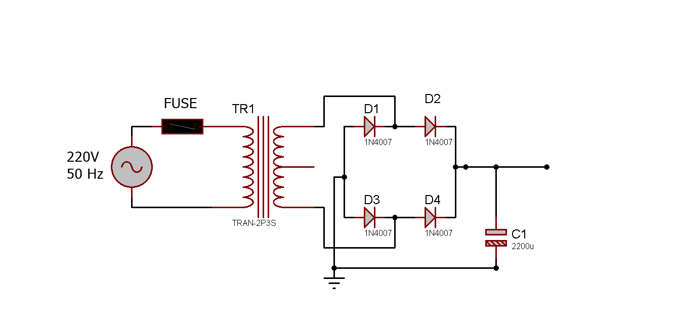 Fig 1.2: Bridge rectifier with Filter

**5.2:Voltage adjustable and regulation:**

Here we use a regulator and adjustable IC (LM317). We give 35v input to the IC. A 10kvariable resistor use for vary the output .One diodes (1N4002) are used for protecting the IC .Capacitor are used for make the input and output perfect DC .When the variable resistor varies from 0 to 10k then the output also varies from 1.2V to 35V.

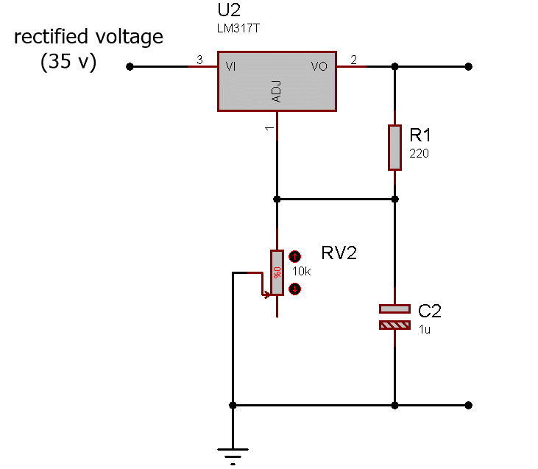

Fig 1.3: voltage adjustable and regulation.

**5.3: Short Circuit Protection:**

Just after the output of the regulator, a combination of two transistors and some resistors are seen. This is the basic short circuit protection unit. When the load is short circuited there will be no potential difference between the emitter and base of transistor Q2. So the total current will flow through the transistor Q1 and to the ground. When the short circuit is separated the current will again start flowing through the normal path. This way the load will be protected if short circuit occurs.

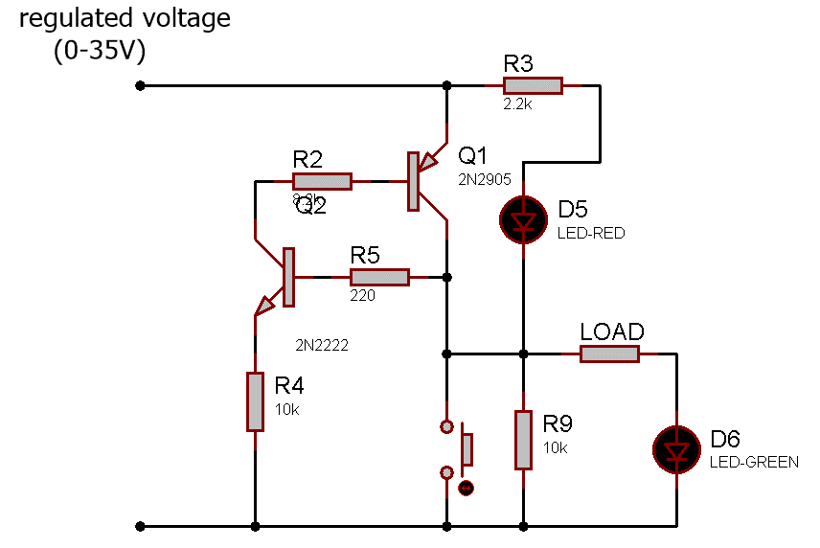

Fig 1.4: Short circuit protection

5.4:**Over Voltage Protection:**

The following portion performs over voltage protection. Rectified output is applied across voltage divider portion. Using zener diode a reference voltage is set which is applied to the inverting terminal of an Op-Amp. Again using a voltage divider combination a portion of rectified voltage is applied in the non-inverting terminal. When rectified output changes, input voltage of non-inverting terminal also changes and when it goes above reference voltage then comparator gives output voltage and Q4 becomes on and hence relay isolate the DC power supply.

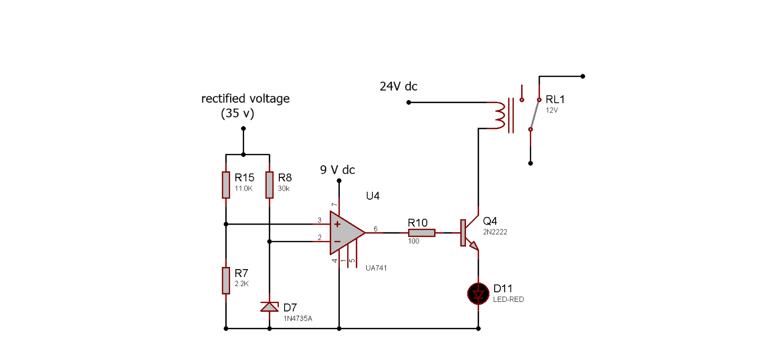

Fig 1.5: Over voltage protection

In this circuit, the reference voltage is 6V. If rectified output is above 40V, then non-inverting terminal voltage will be above (40*2.2/14.2)V or 6.1V and circuit will sense it as over voltage and power supply will be isolated. Here, LM7809 of Fig-1.1 has been replaced by 9V DC and LM7824 has been replaced by 24DC for simplification...

5.5: **Under Voltage Protection:**

This circuit provides under voltage protection. Rectified output is applied across voltage divider portion. Using zener diode a reference voltage is set which is applied to the non*-*invertingterminal of an Op-Amp.Again using a voltage divider combination a portion of rectified voltage is applied in the inverting terminal. When rectified output changes, input voltage of inverting terminal also changes and when it goes reference voltage then comparator gives output voltage and Q3 becomes on and hence relay isolate the DC power supply.

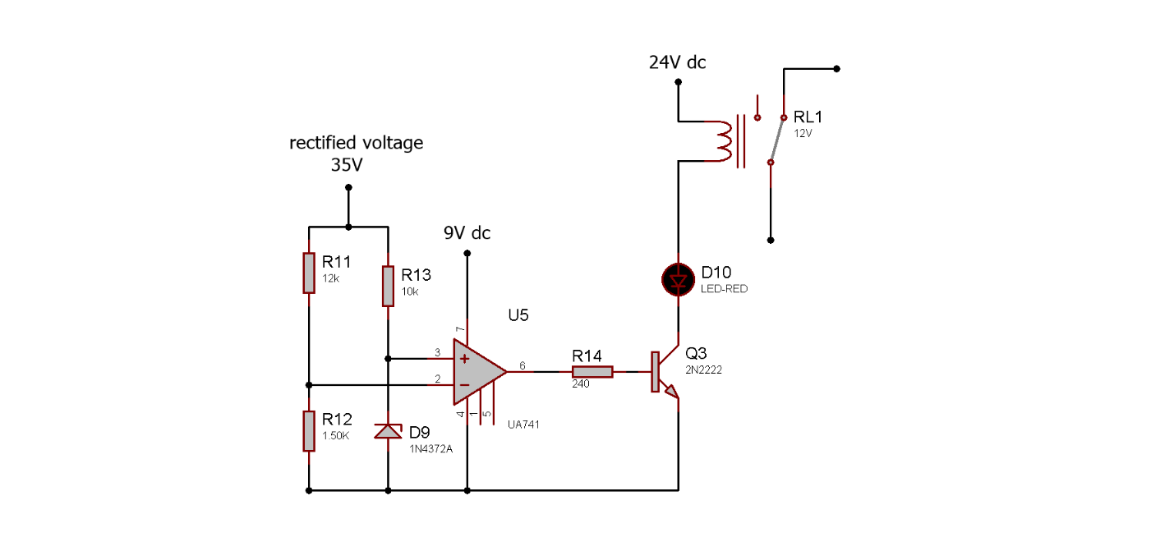

Fig: 1.6: Under voltage protection

In this circuit, the reference voltage is 3V. If rectified output is under 27V, then inverting terminal voltage will be under (27*1.5/13.5)V or 3V and circuit will sense it as under voltage and power supply will be isolated. Here, LM7809 of fig: 1.1 has been replaced by 9V DC and LM7824 has been replaced by 24V DC for simplification.

**5.6: Provide Uninterrupted Supply:**

To provide an uninterrupted power supply a backup battery is used in our circuit design. The battery is connected to LM317 IC through a Relay. The coil of this relay is further connected to the coil of relay 1. And the other leg of the coil of Relay 2 is connected to the transistors of the portion of Over & Under voltage protection. When under or over voltage occurred in the circuit current, currentbecome to flow through both of the coil of Relay 1 and Relay 2. So both of the relay switch the other leg. Thus Relay 1 cut the supply of rectified voltage to load and Relay 2 connect the backup battery to load.

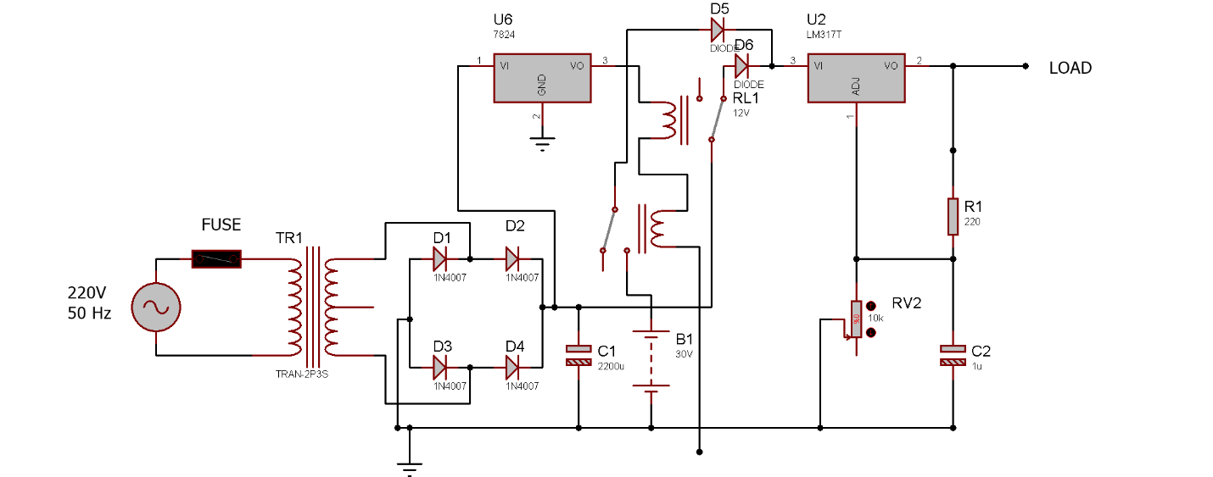

**Fig 1.8: back up battery**

**6: Result analysis:**

* Transformer input=220 V ac.
* Transformer output=24 V ac, 1000mA
* Output after filtering=36V DC.
* Maximum output current=34 mA.
* Input supply voltage range for operation =180~240 V ac.
* Output voltage range=1.25V~35V DC.
* Current consumption by short circuit portion is 11mA.
* Input current (without load) at 35V is 40mA.
* Input power = 1.2 W
* Output power = 0.65 W
* Minimum Load = 120 Ohm
* Maximum Load = 1 M ohm
* Output Ripple = 12 mV

V-I Charecteristics: using 10K ohm Load Resistance

|  |  |
| --- | --- |
| Voltage (V) | Current(mA) |
| 03 | 0.042 |
| 05 | 2.5 |
| 10 | 04 |
| 15 | 06 |
| 20 | 09 |
| 25 | 13 |
| 30 | 16 |
| 34 | 18 |

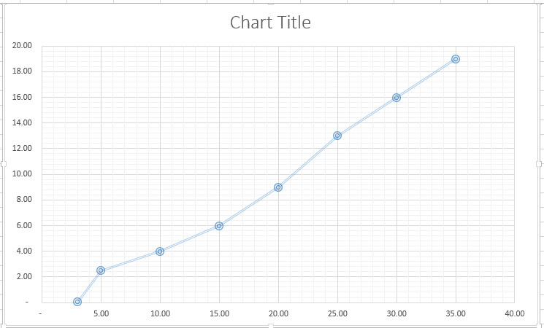

|  |  |  |  |  |
| --- | --- | --- | --- | --- |
| **S.L**  **No.** | **Name** | **Price per piece (Tk.)** | **Quantity** | **Price (Tk.)** |
| 1 | Transformer | 90 | 1 | 90 |
| 2 | Diode | 2 | 6 | 12 |
| 3 | Zener Diode | 2 | 2 | 4 |
| 4 | Capacitor | 25 | 1 | 25 |
| 5 | Resistor | 1 | 14 | 14 |
| 6 | Op-Amp | 20 | 2 | 40 |
| 7 | IC | 10 | 3 | 30 |
| 8 | Transistor | 10 | 4 | 40 |
| 9 | Relay | 25 | 2 | 50 |
| 10 | LED | 1 | 3 | 3 |
| 11 | Variable resistor | 12 | 3 | 36 |
| 12 | Barrow board, solder, others | - | - | 55 |
| 13 | **TOTAL =** |  |  | 359 |

**6: Cost analysis**

**Graph: Performance comparison**

Fig-1.8:Comparison between our product & lowest price market product

**7: Discussion:**

In this project, a DC power supply has been made which provides excellent short circuit protection, over voltage protection, under voltage protection & also provides uninterrupted supply from battery even if the main AC power supply is absent. In over voltage& under voltage protection, Op-Amp is used as comparator and if AC supply exceeds 240V or goes below 180V then over voltage & under voltage unit respectively isolates the circuit after rectified output.

But it has some deficiencies such as it can provide maximum 36mA current and it has also power loss. The maximum output current of the transformer used in the circuit is 1000mA and adjustable regulator IC LM317 is 1.5A. Hence, by using transformer having high current rating and replacing LM317 by LM150/ LM350 (maximum output current=3A) or LM338 (maximum current 5A) the maximum DC output current can also be increased.

**8. Conclusion:**

The dc power supply that we have that we have created provides us regulated and adjustable power supply. Moreover our circuit is short circuit, over and under voltage protected. This dc power supply is better than the available dc power supply in the market. As rating of the equipment is suitable for this circuit and the total cost is quite low from the market cost. At a whole this project will help us for our several future projects.

**9: Fields to develop**

The output voltage changes with load. It isn’t stable. The current rating is also very low. Adjustment can be made to make it more efficient. Using the supply for a long time makes the IC’s unstable. Better adjustment should be made.

**10: References:**

* Electronic Devices And Circuit Theory-

-by Robert L. Boylestad, Louis Nashelsky,

- Ninth Edition, 2007-08.

* Electronic Devices & Circuits-

-by Jacob Millman, Satyabrata Jit

2ndedition.

* Principles of Electronics-

-by V.K Mehta, Rohit Mehta,S. Chand

& Company,2005.

* Internet-

[*http://techlib.com*](http://techlib.com)

[*http://www.electroschematics.com*](http://www.electroschematics.com)

*http://en.wikipedia.org*